Cursors

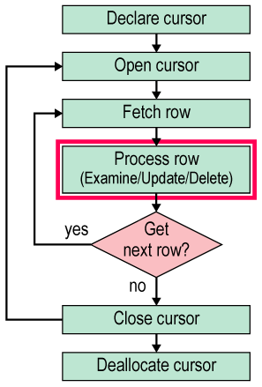

-- is a mechanism that processes the result row-by-row

declare s_cur cursor
for select st_id,st_fname from student
for read only --update

declare @id int
declare @name nvarchar(50)
open s_cur
fetch s_cur into @id,@name
begin
While @@fetch_status=0 --returns 0 success -- 1 failed --2 no more rows to fetch
begin
select @id,@name
fetch s_cur into @id,@name
end
end
close s_cur
deallocate s_cur

declare t_cur cursor
for select t_id,t_name,sal from teacher
for update

declare @id int
declare @name nvarchar(50)
declare @s int
open t_cur
fetch t_cur into @id,@name,@s
begin
While @@fetch_status=0
begin
if @s<1000
begin
update teacher set sal= @s*1.10
where current of t_cur
fetch t_cur into @id,@name,@s
end
end
end
close t_cur
deallocate t_cur

// set cursor rows 5 for biz_book

backup database iti2
to disk='d:\db\iti.bak'

